

National College of Ireland

**B.Sc. Honours in Computing, Year 3 (BSHC3A)**

**B.Sc. Honours in Computing (Evening), Year 3 (BSHC3E)**

**Semester 2 Examinations – May 2023**

______________________________________________________________________

**Software Applications for Business – Project Fact Sheet**

Sean Bonner

**Instructions:** This document should be completed as a team. Only ONE document should be submitted by the team overall. Each member of the team will be responsible for completing their own aspects of the document and activity log.

**Note:** Replace the text in red with your own paragraphs and data.

# Executive Summary

Our project was based around the MCTV business, and we had to carry out tasks such as creating a micro-database, using Git hub, making a website, creating a PowerPoint presentation, using Trello, and working on branding.

# Project Introduction

<insert a paragraph that explains your project and why it is being undertaken. This is usually a single paragraph of text, but may include bulleted lists or other formatting where appropriate>

. Our team consisted of four members: Ryan, Benit, Richard, and Qudus. Our project focused on MCTV, a small family business located in Limerick. Each member of the group chose a different character and worked on various tasks throughout the project. Our tasks included

* database management,
* UML charts,
* Trello charts,
* website development. ,
* GitHub

We divided the tasks among ourselves and provided assistance to each other on how to carry out each task.

The main objective of our project was to allow each team member to gain a better understanding of each section of the project and learn how to complete tasks independently. Our goal was to help develop small businesses through the use of technology. By creating a website and database for MCTV, we hoped to help them become more mainstream and increase their customer base

# Scope

<scope should include information on what is being completed as part of the project and, importantly, what is not within the scope of the project. You may use tables/bullet listes etc. whatever format you think is best and easiest to understand>

listed above the main task within this project include

* github
* data base
* uml charts
* Trello charts

These tasks were essential components of our project and helped us achieve our goals for the MCTV business:

GitHub: We used GitHub as an internet hosting service for our software development project. We created an account and uploaded our website to GitHub, which helped us improve our website and make it more user-friendly.

Database: Using an Excel sheet, we transferred the data into a new database for the MCTV business. This helped us organize the data more effectively and make it easier to access and manage.

UML charts: Based on the results from the new database, we created UML charts that provided a visual representation of the data. These charts helped us identify patterns and trends, which we used to make informed decisions about the business.

Trello charts: We used Trello to keep track of the project and stay on top of our tasks. This allowed us to manage our time effectively and ensure that we completed all tasks within the given timeframe.

# Project Links

<include any links to tools or useful resources that you used during your project. You MUST include the links for your Trello board and your WordPress site at minimum>

|  |  |
| --- | --- |
| Description | Link (URL) |
| Word press link | https://mctv11.wordpress.com/other-team-work/ |
| Trello board link | https://trello.com/invite/b/NKtWwlz9/ATTI34f0395b52239ec048f104f82f1439f3BBC60D10/microsoft-access |
|  |  |
|  |  |
|  |  |

# Roles and Responsibilities

<here you should include a table that lists the team members of the project team and what role they are playing as part of the project.>

|  |  |  |  |
| --- | --- | --- | --- |
| Name | ID (student #) | Role | Responsible for: |
| Ryan hayden | X22323161 | mark | Website (wordpress),factsheet and gitub  And uml chart |
| Richard |  | Roberta | Data base and |
| qudus |  | derek |  |
| benit |  | liam | Trello chart |
|  |  |  |  |

# Activity Log

<here you should list the activities completed by each team member each week. Each team member must complete these each week *individually*. It is recommended to use a shared document to avoid multiple copies with differing information>.

Ensure you copy and paste the table as many times as is required for the number of weeks that your team worked on this project.

It is expected that each team would have a minimum of 4 weeks recorded in the activity log

## Week A

|  |  |  |  |
| --- | --- | --- | --- |
| Team member | What did you complete this week? | What was completed last week? | Were there any issues/challenges found? |
| Ryan | Research | Research on how to create account on wordpress and how to make a website | Forgetting my password and making a new account |
| Richard | Research data base | How to make a data base with the information | none |
| Benit | Started Trello chart | Made an account of the Trello charts | none |
| qudus | Research | research |  |
|  |  |  |  |

## Week B

|  |  |  |  |
| --- | --- | --- | --- |
| Team member | What did you complete this week | What was completed last week | Were there any issues/challenges found? |
| ryan | Made home page on word press | First page | none |
| Richard | Started working on the first account customer | Half of the costumer account | Learning how to make the page |
| Benit | Helped with data base |  | none |
| qudus | Research | Research |  |
|  |  |  |  |

<insert a screenshot of your Trello board here each week>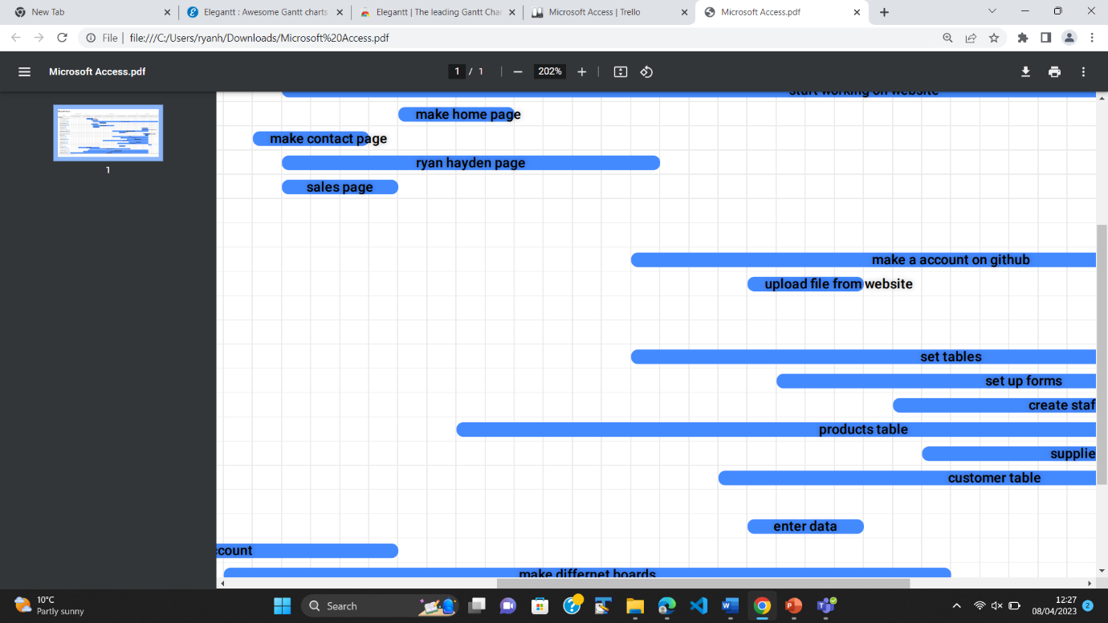

## Week C

|  |  |  |  |
| --- | --- | --- | --- |
| Team member | What did you complete this week | What was completed last week | Were there any issues/challenges found? |
| ryan | Made the website and started doing the fact sheet and started learning how to upload github | Made website | Team members |
| richard | Supplier account | Suppliers account | none |
| Benit | Supplier account |  |  |
| qudus | Assist team |  |  |
|  |  |  |  |

<insert a screenshot of your Trello board here each week>

## Week d

|  |  |  |  |
| --- | --- | --- | --- |
| Team member | What did you complete this week | What was completed last week | Were there any issues/challenges found? |
| ryan | Made a github account and helped with Trello | Update the website , made Trello account and made githbu work | none |
| richard | Stock items | Stock iteam | none |
| Benit | Looked over other accounts and made sure everything was ok |  |  |
| qudus | Assist team |  |  |
|  |  |  |  |
|  |  |  |  |

## Week e

|  |  |  |  |
| --- | --- | --- | --- |
| Team member | What did you complete this week | What was completed last week | Were there any issues/challenges found? |
| ryan | Powe point and made sure everyone was doing there work .got people work and made folder | powerpiont | none |
| richard | Looked over accounts and made uml charts | Suppliers account | none |
| Benit | Made the Trello chart |  |  |
| qudus | Assist team |  |  |
|  |  |  |  |

# Project conclusion

<include here information on the outcomes from the project, what went well, what didn’t, and what might need further work/enhancement.

The project was interesting and different from most projects, which are usually boring. It provided an insight into future careers and how businesses operate. This project gave us the opportunity to develop our skills and learn how to develop small businesses with and without technological advancements.

Within this project, some things went well, some didn't, and there were things we could have worked on:

Things that went well:

The website development went well. By carrying out research in the first week, we developed our ideas and understanding of how to create a website, database, and other areas. This research helped us understand how to complete the tasks to a high standard, which made the project mostly plain sailing.

Things that didn't go well:

Working with a group of four other people was difficult. With a big group, some team members didn't get involved until one or two days before the project was due, which led to some members doing most of the project. Group projects are a good opportunity to work together, but they can have negative effects. Additionally, Trello charts didn't work correctly, and the website didn't save, causing me to redo the work.

Things I need to work on:

The database needs more time to be worked on, and the website's branding could be improved by using different brand colors. Starting the project earlier would have allowed us to improve the final outcome.